Matthew Schwartz

Computational Physics

March 9, 2018

One-Dimensional Modeling of Plant Growth

How does the growth of plants depend on time? How do biological factors affect the speed of growth and the sizes of plants? What patterns emerge? These are questions which I wish to address through the modeling of plant growth. As so much of our world is inhabited by plant life, it is imperative that we understand how they function – just as we seek to understand how the human body functions.

My model will be strictly one-dimensional. In the first iteration of my model, I plan to represent a plant as a line, fixed at one end (the ground), x = 0, and whose other end evolves with time x = L(t). At the core of this model is the following equation:

$$\frac{dL}{dt}=f\left(R\right)$$

That is, the rate of plant growth is equal to some function of R, which is a concentration of metabolites involved with growth. In *Dynamical Models of Plant Growth* (Bessenov and Volpert), *f(R)* (shown below) is chosen to be a piecewise function that is 0 up until a critical value, Rf and then some constant value f0. This, they claim, is consistent with plant morphogenesis. To fully know the speed of growth, however, we must also know R(t). This is governed by:

$$h\frac{dR}{dt}=g\left(R\right)C- σR$$

where *g(R)* is another piecewise function (shown below). The first term on the right describes production of a growth factor in the stem, while the second corresponds to its consumption. Finally, C represents the concentration of nutrients throughout the stem. Thus, in its full form, C = C(x,t), and the evolution of C over space and time is described by the diffusion-advection equation (with appropriate boundary conditions). For simplicity, my initial model will treat C as either constant, or a simple function of space or time, alone.

Thus, in my first iteration, I will solve numerically two first order linear differential equations. I intend to solve these equations with a variety of numerical methods, starting with a simple Euler method and working up to Runge-Kutta methods, perhaps with adaptive time steps. The output of this model will be a simulation of plant growth with time, along with several instructive plots. Because these equations are analytically soluble (depending on choice of C), I will be easily able to verify the accuracy of my results.

In my second iteration, I would like to implement branching. The model will still be one-dimensional – plant growth occurring along a line. Moreover, the equations and assumptions concerning such growth will remain the same. I simply intend to add in conditions that will dictate if and when one stem will branch off. According to *Bessenov and Volpert*, the condition for branching is determined by critical values of two hormones, A0 and K0. The concentrations of these hormones are, like C, described by the diffusion-advection equation. Once again, I will relax the assumptions on A(x,t) and K(x,t) by treating them as functions of time, alone. In this way I will reduce the equations from partial differential to ordinary differential equations.

If time permits, I may attempt a third iteration which simply expands upon my previous models by treating C, A, and K as functions of space as well as time, and implementing numerical methods (such as FTCS) to solve the appropriate PDEs. It may also be of interest to add to the branching model a preferred direction (i.e. to maximize sunlight) rather than implementing a constant branching angle.

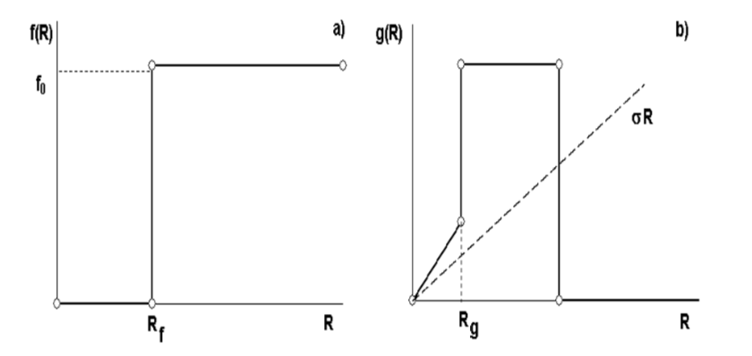

References

* *Dynamical Models of Plant Growth,* N. Bessenov and V. Volpert